**PUSL2010 Analysis**

In the given scenario we must implement a supermarket infrastructure to make the current transactions efficient. The supermarket infrastructure consists of

* Sales outlets (supermarkets)

Provide shopping facilities to online and traditional Customers. The Online purchases will be delivered via transport or customers will be able to pick it from the nearest supermarket.

* Storage and logistic centers.

The stocks sent from farms will be stored here .Depending on the demand provide supermarkets with stocks.

* Transportation system

Transport goods from each outlet.

* Head office

Implement security via a command and control station.

Communicate to any outlet , security focal point via and AOIP .

Monitor every location via CCTV.

Track transportation via GPS and IOT .

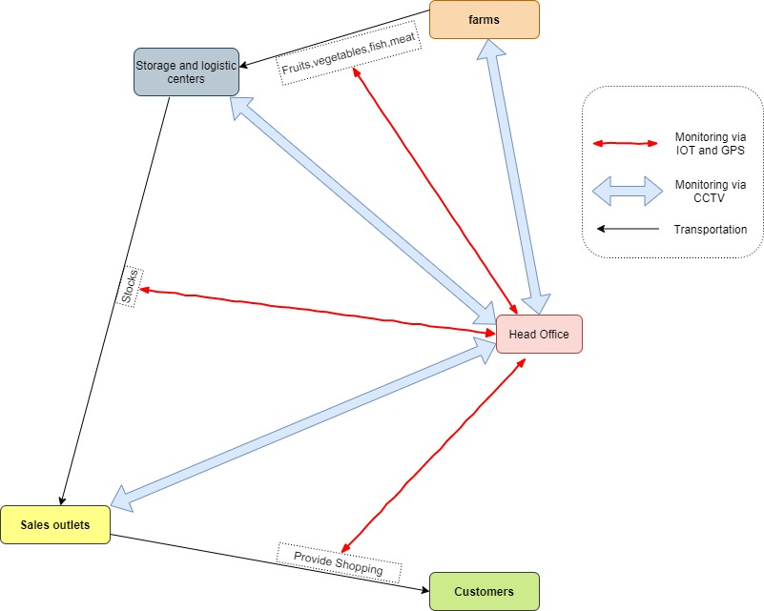

# Objective

Provide a detail proposal about all the possible infrastructure and decide the best cause the company should take to enhance their Supermarket chain system.

# Requirements

* Explain the possible infrastructures in detail (the technologies they use)
* Identify the External and internal users of the current system
* Compare each of these infrastructures with one another(Identify weaknesses and strength of each Infrastructure).
* The current trends / technologies used in Supermarket industry .
* Why the selected infrastructure is better to the given scenario() ?
* Diagrams of the implemented Infrastructure